Indexing and Query Optimization
Enhancing database performance by reducing data scanned, disk I/O, and query execution time.

1. INDEXING
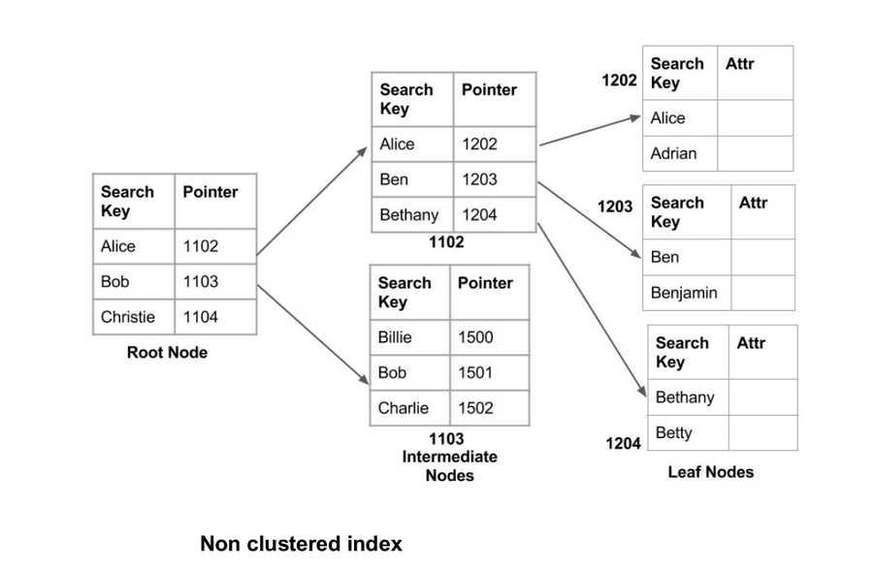
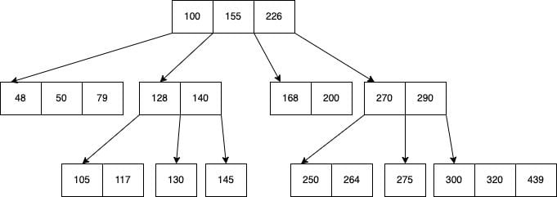
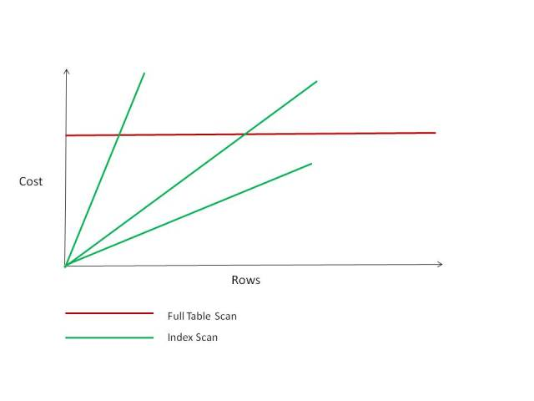
Definition
Indexing is a database optimization technique where a separate data structure (commonly a B-Tree) is created on one or more columns. This structure allows the database to locate rows quickly without scanning the entire table.
Indexing works like a book index. Instead of reading all pages, the database jumps directly to the relevant location.

Use Case
Indexing is used when queries frequently filter data using WHERE conditions, join tables on keys, or perform range searches. Common examples include searching users by email, fetching orders by customer ID, and performing incremental ETL loads using timestamps.

BASIC LEVEL – Single Column Index
Step 1: Create Table
CREATE TABLE orders (
order_id INT,
customer_id INT,
order_date DATE,
amount INT
);
Step 2: Insert Sample Records
INSERT INTO orders VALUES
(1,101,'2025-01-01',500),
(2,102,'2025-01-01',700),
(3,101,'2025-01-10',900),
(4,103,'2025-02-05',300),
(5,101,'2025-02-10',1200);
Step 3: Query Without Index
SELECT * FROM orders WHERE customer_id = 101;
What Happens Internally
The database checks each row one by one to see if the customer_id matches. This is called a full table scan and becomes very slow as data grows.
Step 4: Create Index
CREATE INDEX idx_customer ON orders(customer_id);
Step 5: Same Query With Index
SELECT * FROM orders WHERE customer_id = 101;
What Happens Now
The database uses the index to jump directly to rows where customer_id equals 101. Only matching rows are read, which is significantly faster.

INTERMEDIATE LEVEL – Composite Index
Definition
A composite index is created on multiple columns and is useful when queries filter on more than one column.
Example
CREATE INDEX idx_customer_date
ON orders(customer_id, order_date);
Query
SELECT * FROM orders
WHERE customer_id = 101
AND order_date >= '2025-01-01';
What Happens
The database first narrows results by customer_id and then applies the date condition using the same index. This is highly efficient for analytics and ETL jobs.

ADVANCED LEVEL – Covering Index
Definition
A covering index contains all the columns required by the query, allowing the database to answer the query without accessing the table itself.
Example
CREATE INDEX idx_cover
ON orders(customer_id, amount);
Query
SELECT amount FROM orders WHERE customer_id = 101;
What Happens
The database retrieves the result directly from the index. No table scan occurs, resulting in maximum performance.

Indexing Limitations
Indexing increases storage usage and slows down insert and update operations because indexes must also be updated. Creating too many indexes can negatively impact performance.

2. PARTITIONING
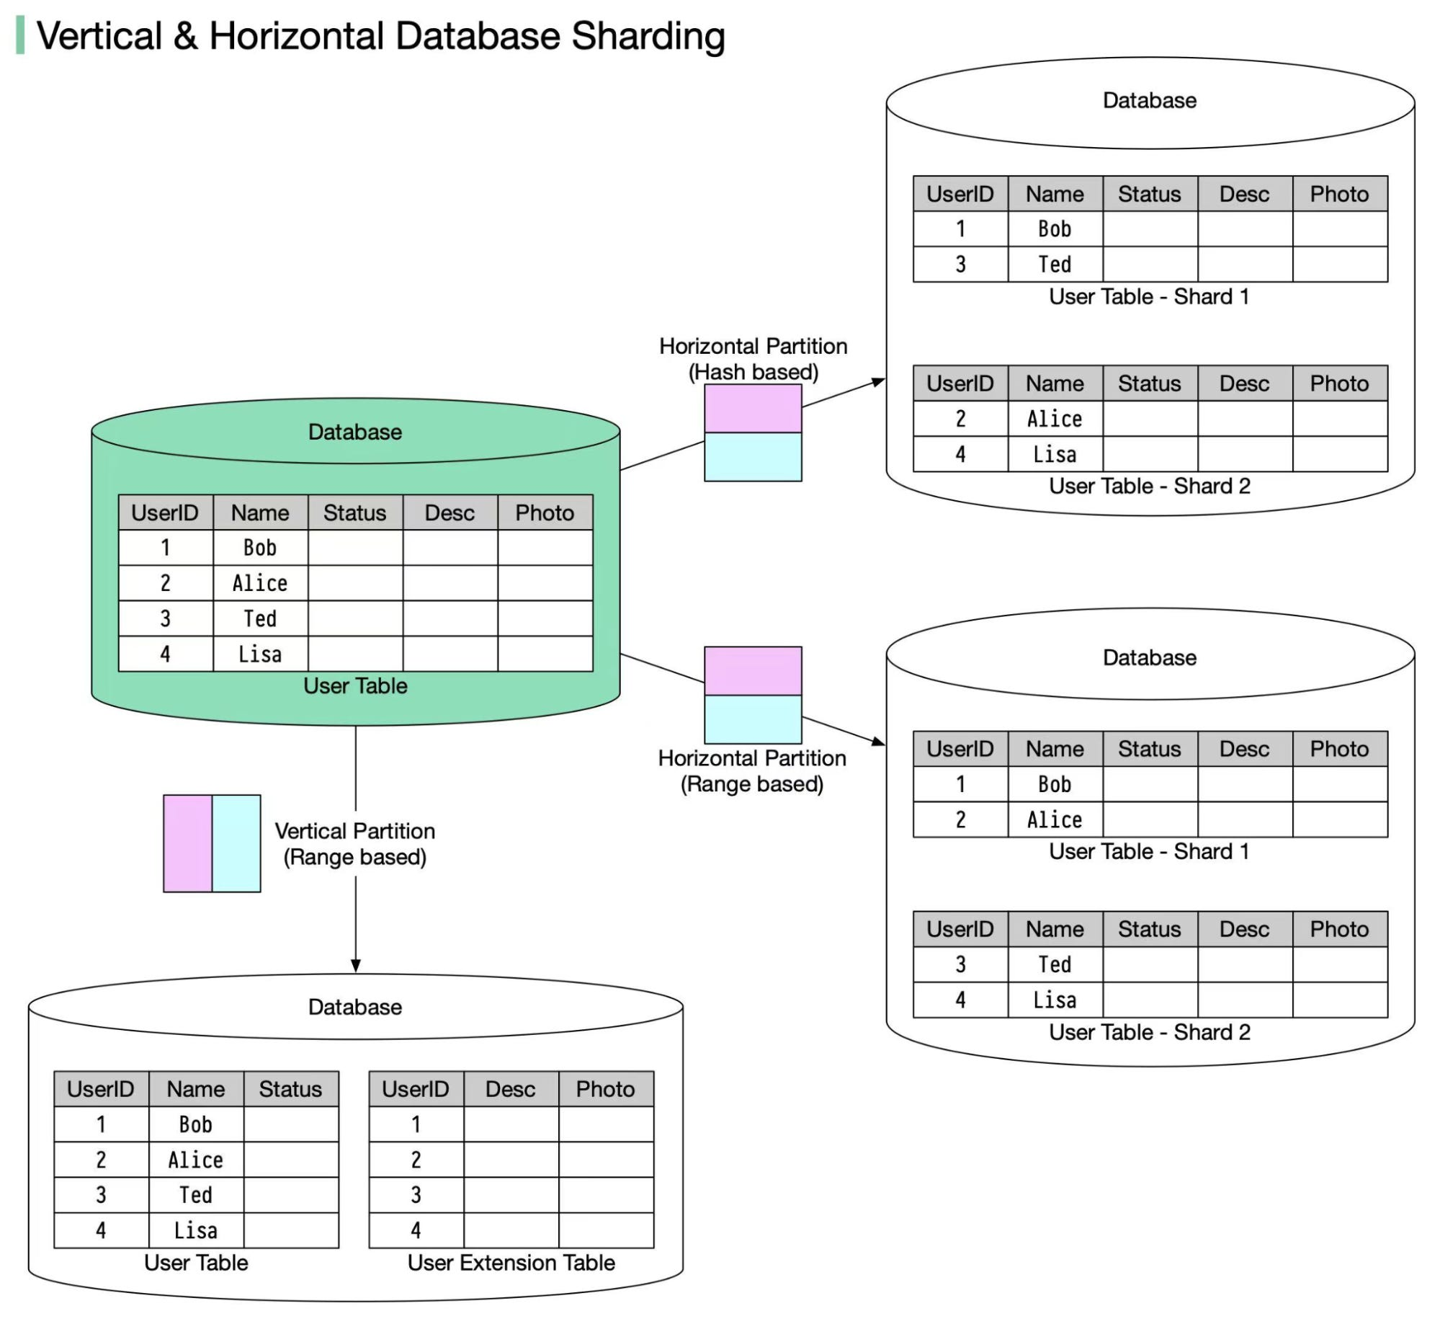
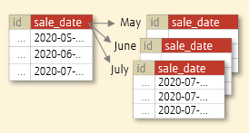
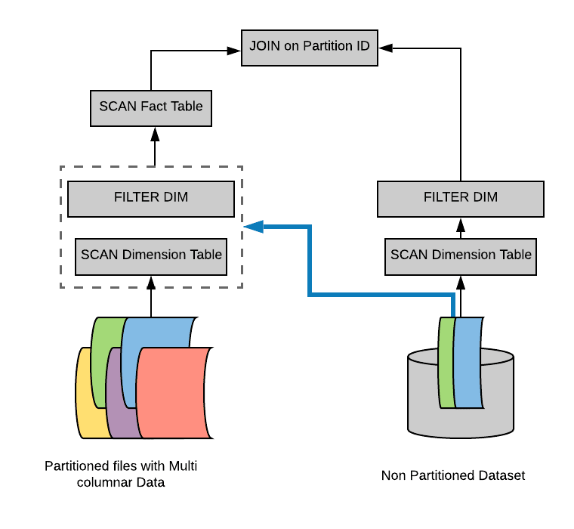
Definition
Partitioning divides a large table into smaller logical sections called partitions. Each partition stores a subset of the data, but the table still appears as a single table to the user.

Use Case
Partitioning is used for very large tables such as transaction data, logs, and time-series records. It improves performance and simplifies data management.

BASIC LEVEL – Range Partitioning
Step 1: Create Partitioned Table
CREATE TABLE sales (
id INT,
sale_date DATE,
amount INT
)
PARTITION BY RANGE (MONTH(sale_date)) (
PARTITION p_jan VALUES LESS THAN (2),
PARTITION p_feb VALUES LESS THAN (3)
);
Step 2: Insert Data
INSERT INTO sales VALUES
(1,'2025-01-01',500),
(2,'2025-01-10',900),
(3,'2025-02-05',300);
Step 3: Query
SELECT SUM(amount)
FROM sales
WHERE sale_date = '2025-01-10';
What Happens
The database identifies that the date belongs to January and scans only the January partition. Other partitions are ignored. This process is called partition pruning.

INTERMEDIATE LEVEL – Hash Partitioning
Definition
Hash partitioning distributes data evenly using a hash function on a chosen column, such as customer_id.
Example
PARTITION BY HASH(customer_id)
PARTITIONS 4;
What Happens
Data is evenly distributed across partitions, allowing better parallel processing and high concurrency.

ADVANCED LEVEL – Partitioning with Index
Example
CREATE INDEX idx_sales_date ON sales(sale_date);
Query
SELECT SUM(amount)
FROM sales
WHERE sale_date BETWEEN '2025-01-01' AND '2025-01-31';
What Happens
The database first performs partition pruning to select the January partition and then uses the index inside that partition for faster data access.

Partitioning Limitations
Partitioning increases schema complexity and requires careful selection of the partition key. It is not beneficial for small tables.

3. CACHING
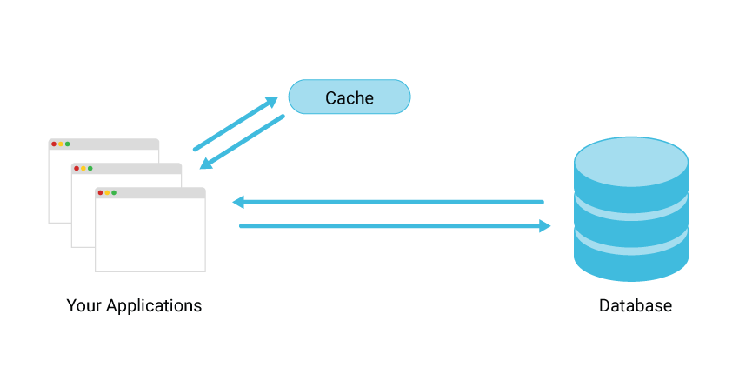

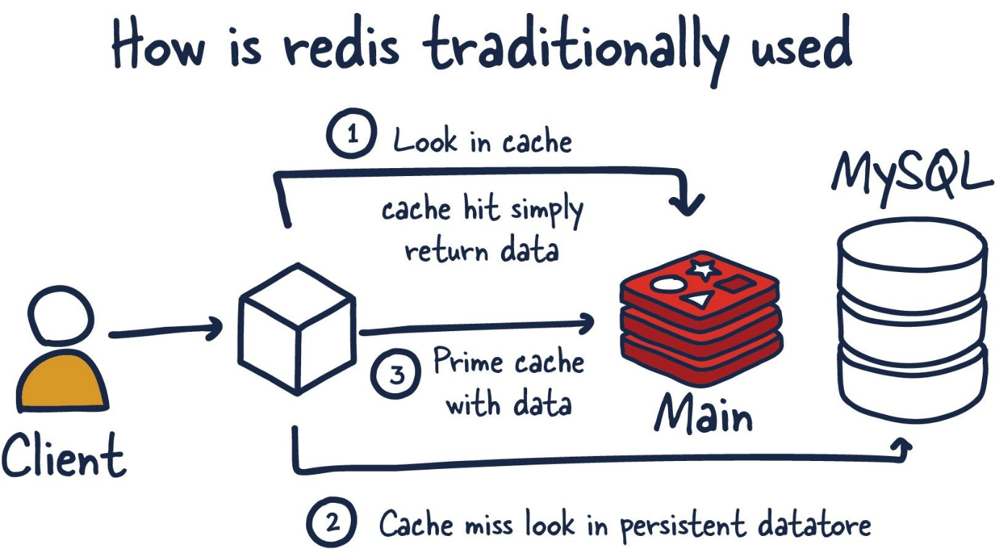
Definition
Caching stores frequently accessed data in memory so that repeated queries do not hit the database. Memory access is significantly faster than disk access.

Use Case
Caching is used in dashboards, APIs, lookup tables, and analytical queries that are executed repeatedly.

BASIC LEVEL – No Cache
SELECT SUM(amount) FROM orders WHERE customer_id = 101;
What Happens
Every request executes the query against the database, increasing load and response time.

INTERMEDIATE LEVEL – Application Cache (Python)
cache = {}

def get_total(cid):
if cid in cache:
return cache[cid]
result = run_sql_query(cid)
cache[cid] = result
return result
What Happens
The first request fetches data from the database. Subsequent requests are served from memory.

ADVANCED LEVEL – Distributed Cache (Redis)
Example
r.setex("total:101", 300, result)
Cache Invalidation
r.delete("total:101")
What Happens
The database is accessed only when the cache is empty or expired. This significantly improves scalability and performance.
Final Summary
Indexing reduces the number of rows searched.
Partitioning reduces the amount of data scanned.
Caching eliminates repeated database access.
Python only sends queries. All performance gains come from database design and architecture.

